**Lab Report. 02**

**Title: Lab Report**

*Course title: Computer Graphics Lab*

*Course code: CSE-304*

*3rd Year 1st Semester 2022*

**Date of Submission**: 04/06/2023



###### **Submitted to-**

###### Dr. Mohammad Shorif Uddin

###### Professor

*Department of Computer Science and Engineering*

*Jahangirnagar University*

*Savar, Dhaka-1342*

*And*

*Dr. Morium Akter*

###### Associate Professor

*Department of Computer Science and Engineering*

*Jahangirnagar University*

*Savar, Dhaka-1342*

|  |  |  |  |
| --- | --- | --- | --- |
| **Sl** | Class Roll | Exam Roll | Name |
| 01 | 369 |  | Yumna Tasneem |

Scan conversion of ellipse:

Source code:

|  |  |
| --- | --- |
| #include<iostream>  #include<graphics.h>  using namespace std;  void drawellipse(int xc, int yc, int a, int b)  {  int x=0;  int y=b;  int a_sqr = a*a;  int b_sqr = b*b;  int two_a_sqr = 2*a_sqr;  int two_b_sqr = 2*b_sqr;  int p;  int px = 0;  int py = two_a_sqr*y;  p = b_sqr - (a_sqr*b)+(0.25*a_sqr);  while(px<py)  {  putpixel(xc+x,yc+y, WHITE);  putpixel(xc-x,yc+y, WHITE);  putpixel(xc+x,yc-y, WHITE);  putpixel(xc-x,yc-y, WHITE);  x++;  px += two_b_sqr;  if(p<0)  {  p += b_sqr+px;  }  else{  y--;  py -= two_a_sqr;  p += b_sqr + px-py;  }  } | while(y>=0)  {  putpixel(xc+x,yc+y, WHITE);  putpixel(xc-x,yc+y, WHITE);  putpixel(xc+x,yc-y, WHITE);  putpixel(xc-x,yc-y, WHITE);  y--;  py -= two_a_sqr;  if(p>0)  {  p += a_sqr - py;  }  else  {  x++;  px += two_a_sqr;  p += a_sqr - py+px;  }  }  }  int main()  {  int gd = DETECT, gm;  initgraph(&gd, &gm, "");  int xc,yc,a,b;  cout << "Enter the center coordinate of the ellipse: " << endl;  cin >> xc >> yc;  cout << "Enter the length of the major axis: " << endl;  cin >> a;  cout <<"Enter the length of the minor axis: "<< endl;  cin >> b;  drawellipse(xc,yc,a,b);  delay(500000);  closegraph();  return 0;  } |

Output:

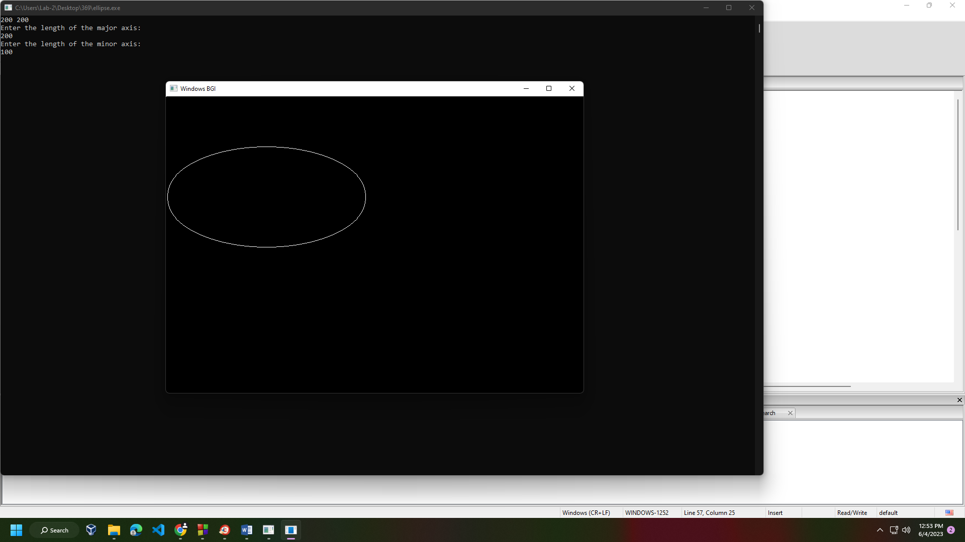

Scan conversion of midpoint of a circle:

Source code:

|  |  |
| --- | --- |
| #include <iostream>  #include <graphics.h>  void drawCircle(int xc, int yc, int radius)  {  int x = 0;  int y = radius;  int d = 1 - radius;  int deltaE = 3;  int deltaSE = -2 * radius + 5;  while (y > x)  {  putpixel(xc + x, yc + y, WHITE);  putpixel(xc + x, yc - y, WHITE);  putpixel(xc - x, yc + y, WHITE);  putpixel(xc - x, yc - y, WHITE);  putpixel(xc + y, yc + x, WHITE);  putpixel(xc + y, yc - x, WHITE);  putpixel(xc - y, yc + x, WHITE);  putpixel(xc - y, yc - x, WHITE); | if (d < 0)  {  d += deltaE;  deltaE += 2;  deltaSE += 2;  }  else  {  d += deltaSE;  deltaE += 2;  deltaSE += 4;  y--;  }  x++;  }  }  int main()  {  int gd = DETECT, gm;  initgraph(&gd, &gm, "");  int xc = 250;  int yc = 250;  int radius = 100;  drawCircle(xc, yc, radius);  delay(5000);  closegraph();  return 0;  } |

Output:

